8) How does the detector convert the AC signal into a DC one with an amplitude proportional to the square of the amplitude of the original signal?

Radio telescopes use diodes as ‘detectors’ and they employ a unique property of diodes’ current-voltage characteristic. Below is the I-V characteristic of a p-n junction diode in forward bias-
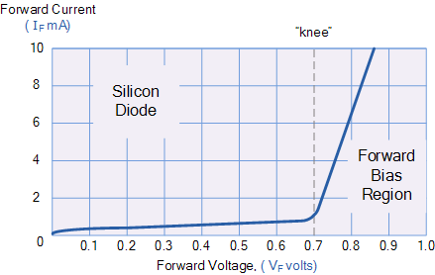

Source: www.electronics-tutorials.ws

Around the ‘knee’ (or ‘cut-in’) point in the graph, the I-V characteristic can be approximated as a quadratic function ie close to the cut-in voltage, the current is proportional to the square of the voltage across the diode. This means that if the input signal’s voltage amplitude is V then the current through the diode is proportional to V² . Now this current passing through a resistor will cause a voltage V’ across it which will again be proportional to V² (by Ohm’s Law). Hence the output of our diode is a signal with an amplitude proportional to the square of the amplitude of the input signal (which is also proportional to the amplitude of the electric field E in the radio signal). The power in radio signal is proportional to E² , so the output of the diode is directly proportional to the power in the radio signal. The diode is called a ‘square-law detector’.

The diode will also act as a rectifier, allowing currents only in one direction. If the the input signal had only one frequency, the output would look like-

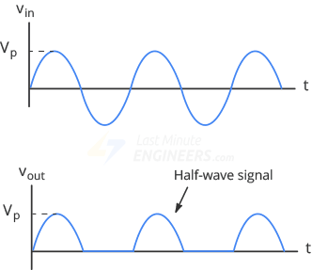

The diode is acting as a half-wave rectifier. We can have the output as a full-wave by using a full-wave rectifier like below

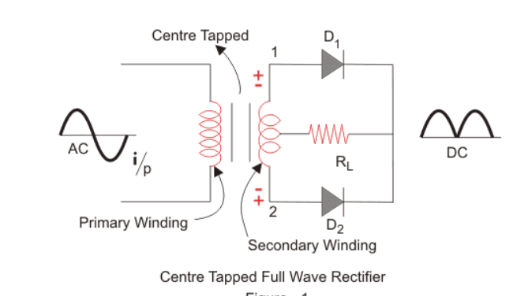

Source: www.electrical4u.com

9) Why does the input signal of the integrator fluctuate rapidly? How does time-averaging smooth out the signal and improve the SNR?

After the detector converts the signal into a DC signal, it still has a lot of noise from all the electronic components prior to the integrator. This noisy component is completely uncorrelated and appears as rapid fluctuations in the signal. The nature of the noise is such that the mean of the fluctuations is 0 ie the noise causes the signal value to fluctuate up and down from original signal value. This means that if we put a lot of noise values on top of each other (meaning, add them) then the sum should approach 0 as the number of such values is increased.

On the other hand, the signal from our astronomical source doesnt comprise of random fluctuations about 0 mean. They have a positive finite mean and if we add many such values, they will reinforce each other instead of canceling out. So when we take the output of the detector and sum all of the output values within a time range T (called the integration time), the noise component values cancel each other while the astronomical signal values add up. Hence with the desired signal value increasing and the noise value decreasing the signal/noise ratio (SNR) increases and we obtain better sensitivity.

10) Explain the kind of device and its input-output characteristics needed to convert the analog signal into a digital one for recording.

An analog-to-digital converter (ADC) device is used to convert signals from analog to digital form. There are various ways in which the conversion is implemented, one of them is Pulse Code Modulation (PCM). PCM comprises 3 stages – sampling, quantization, encoding.

Sampling – this means taking the signal values only at certain points of time. These values are taken with a particular frequency called ‘sampling frequency’ which is kept more than twice the frequency of the input signal. So the result of sampling is that we have a continuous range of signal values from discrete times.

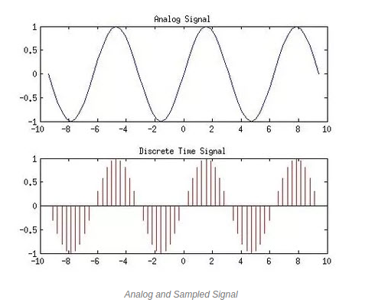

Source - www.elprocus.com

Quantization – The input signal values are bound between a maximum and minimum voltage, V_{max} and V_{min} . This interval is divided into a number of parts which depends on the maximum number of bits the ADC is going to use. The quantizer assigns numbers to these sub-divisions of the voltage interval, starting from 0 So if a particular signal value out of the sampler falls in a sub-division numbered ‘2’, it is assigned that number. So the result of the quantization stage is to turn the analog signal into a discrete time series of quantized integer values.

Encoder – The quantized integer values are then converted into binary numbers which are expressed using a number of bits. So in effect the continuous signal values in the ADC input have been converted into bits of information which can now be fed into a computer for recording.

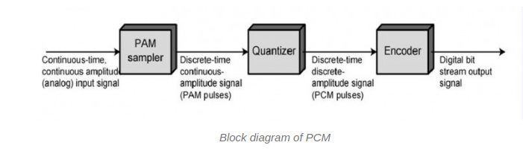
Source - www.elprocus.com

11) What additional features are needed on top of the simple block diagram in order to get the spectral information about the signal and to know the signal's profile for different ranges of frequencies?

In order to get the spectrum of a radio signal, several methods exists some of which are the analog Filter Bank Spectrometer and digital ones like the Auto-Correlation Spectrometer etc. The Filter Bank Spectrometer is described below.

The IF output of the mixer is amplified and sent to the back-end where the whole signal is split into many copies by a power splitter. Each copy enters a separate channel where it is met by a narrow band-pass filter. The filters that the copies pass through filter different-different narrow frequency range so the channels separate the spectral features in the original signal. In each channel the filter is followed by a square-law detector and then fed into the recorder. In this way by adding a power splitter to our simple block diagram and creating separate channels for filtering different frequencies, we can determine the frequency composition of the original signal.
Filters with different frequency bands
Square-law Detectors

Filter

Filter

IF Input
Power Splitter
Filter
Recorder

Filter

Filter

12) To explain the stacking process of pulsar time-series data called 'folding' in detail.

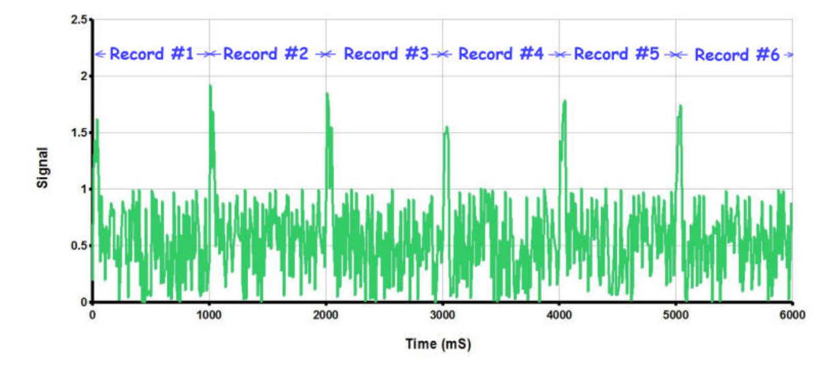
We want to analyse the time-series data from the telescope to look for a possible pulsar detection. The time series looks quite random with a few larger peaks along with many small ones. For example -
Source - http://neutronstar.joataman.net/

The algorithm for folding goes as follows- we decide on a very rough estimate T of the time period of the pulsar and divide it into a number of time-bins. Then we take the time-series and start sampling the data with a particular sampling frequency. We would have multiple sampled values in the span of every time-bin, let the number be n. So the first n sampled values are put in the first bin and the next n sampled values are put in the second bin. This would continue till the last bin after which the next n samples values are put in the first bin again and so on. So we are adding values which are T time apart in the time series. In effect we are chopping the time series at an interval of T and putting all these parts on top of each other.

Now if T isnt equal to the actual period of the pulsar, the values in the same bins wont necessarily add up and an emerging peak wont be seen. An algorithm is used to analyse this folded series and evaluate the likelihood of it having a pulsar detection. Our folding algorithm then changes T by a small amount, creates the time-bins, samples the time-series and folds it just like described above. The favourability of this folded series is also evaluated. This way, various values of the trial time period of the pulsar is tested for the best folded time series. When T is practically equal to the pulsar’s time period, then the pulsar signal values get added on top of each other during folding, reinforcing each other. In other bins, the noise values will get added together and owing to their random symmetrical nature about a value, summing them actually reduces the noise level. The pulsar signal will have a big peak while noise would get weaker, resulting in a high SNR. This folded series would be evaluated to be very likely of a pulsar detection.

